**Teesside University**

**School of Computing**

**Systems Design & Databases**

**COM-1076-N**

**TRA Training Courses Application**

**Individual Document**

**Submitted by MUSA HAMWALA II – Q5047119**

**16 JANUARY 2017**

Table of Contents

Introduction 1

Implementation Model 1

UML Implementation Data Model 1

Figure 1. UML Implementation Data Model 1

Description 1

Data Definition Language 2

Schema 2

Tables 2

SQL Queries 3

Query 1 3

Query 2 3

Query 3 4

Query 4 4

Query 5 4

Code Harness 1

# Introduction

This report documents the development of TRA Training Course Application and database software submitted for assessment for the Systems Design & Databases Module. In the first section I briefly describe the figure below which is my UML Implementation Data Model. The UML Model also acts as the concept design of the database and is the framework of the database. The next part of my report is the SQL code that I used to generate all the tables that are included in my database. Finally, the last section is the queries I wrote in PHP that allows the web front to interact with the database depending on the action you want to take.

# Implementation Model

## UML Implementation Data Model

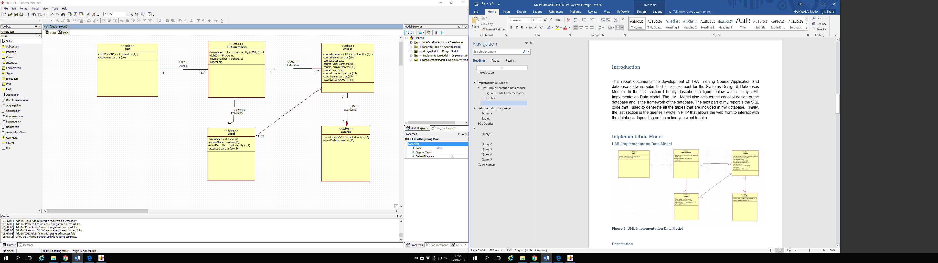

### Figure 1. UML Implementation Data Model

## Description

## 

This figure shows the relationships between all the tables in the TRA database and the attributes that associate with them.

# Data Definition Language

## Schema

use q5047119

go

create schema TRA

## Tables

|  |  |
| --- | --- |
| create table TRA.members  (traNumber int identity(1000,1) not null,  clubID int not null,  courseMember varchar(10) not null,  coach bit not null,  constraint PK_members primary key (traNumber),  constraint FK_club foreign key (clubID)  references TRA.club(clubID) ) | TRA Members table |
| create table TRA.enrol  (traNumber int not null,  courseName varchar(10) not null,  attended varchar(10) not null,  enrolID int identity(1,1) not null,  constraint PK_enrol primary key (enrolID),  constraint FK_members foreign key (traNumber)  references TRA.members(traNumber) ) | Enrolment table |
| create table TRA.course  (courseNumber int identity (1,1),  courseName varchar(10) not null,  courseDate date not null,  courseType varchar(10) not null,  courseTerrain varchar(10) not null,  courseTime time not null,  courseLocation varchar(15) not null,  coachName varchar(15) not null,  awardLevel int not null,  constraint PK_course primary key (courseNumber),  constraint FK_awards foreign key (awardLevel)  references TRA.awards(awardLevel) ) | Course table |
| create table TRA.club  (clubID int identity (1,1) not null,  clubName varchar(10) not null,  memberCount int not null,  constraint PK_club primary key (clubID) ) | Club table |
| create table TRA.awards  (awardLevel int identity (1,1),  awardDetails varchar(10) not null,  constraint PK_awards primary key (awardLevel) ) | Awards table |
| ALTER TABLE Q5047119.TRA.members  ADD coach bit  GO | Alter Query |

# SQL Queries

# 

## Query 1

## 

This query enrols a member on a particular course.

USE [q5047119]

GO

SET QUOTED_IDENTIFIER OFF

INSERT INTO [TRA].[enrol]

([traNumber]

,[courseName]

,[attended])

VALUES

("1023",

"SPRINT",

"n/a")

GO

## Query 2

The purpose of this query is to list the available courses.

USE [q5047119]

GO

SELECT * FROM [TRA].[course]

GO

## Query 3

The purpose of this query is to delete a course from the database

USE [q5047119]

GO

SET QUOTED_IDENTIFIER OFF

DELETE FROM [TRA].[course]

WHERE courseName = "RUNNING"

GO

## Query 4

The purpose of this query is to list the course enrolments, displaying the coaches’ names, attendees’ names and whether or not they attended, and order by course title.

SELECT u.enrolID, u.courseName, c.coachName, c.courseDate, u.enrolID, m.courseMember, u.attended, m.traNumber

FROM TRA.course AS c

JOIN TRA.enrol AS u ON c.courseName = u.courseName

JOIN TRA.members AS m ON m.traNumber = u.traNumber

## Query 5

The purpose of this query is to unenrol a member, but only if they have not completed the course.

USE [q5047119]

GO

DELETE FROM [TRA].[enrol]

WHERE attended = 'False'

GO

# Code Harness

# 

The completed web application can be found here….

<https://scm-intranet.tees.ac.uk/users/q5047119/>

There are 10 queries in total within the code harness.

|  |
| --- |
| 1. Select Members |
| 1. Delete Member |
| 1. Add a Member |
| 1. List Clubs (Member Count) |
| 1. List Members |
| 1. List Courses |
| 1. Delete Courses |
| 1. Enrol on a Course |
| 1. List Course Enrolments |
| 1. Unenrol Member |